ARMY MOUNTAINEERING
ASSOCIATION

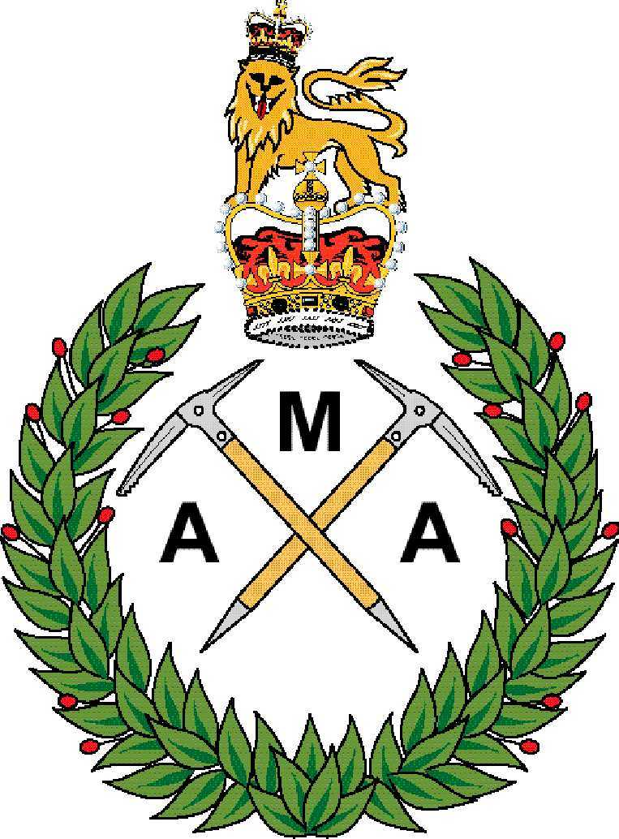

CONSTITUTION

AMA Constitution

1. Name and Address

1.1 The name of the Association shall be the Army Mountaineering Association (AMA).

1.2 The official address of the AMA shall be:

Army Mountaineering Association
JSMTC Indefatigable
Plas Llanfair
Llanfair PG
Anglesey
LL61 6NT

2. Scope and Objectives

2.1 Scope. The AMA embraces the wide range of mountaineering activities, including: use of climbing walls, sport climbing; hill-walking; rock climbing and ice climbing; summer, winter and Alpine mountaineering; ski mountaineering and ski touring; polar exploration; and expeditions to the greater ranges, including high altitude and exploratory mountaineering.

2.2 Objectives. The objectives of the AMA shall be:

a. To promote military efficiency by encouraging mountaineering in the Army.

b. To develop among members a high standard of mountaineering competence by:

(1) Organising climbing meets and supporting mountaineering expeditions.

(2) Giving advice and assistance to the Chain of Command, units and individuals on all aspects of mountaineering.

(3) Providing a link between active Army mountaineers.

c. To advise Army Headquarters on mountaineering matters.

d. To promote and develop Sport Climbing in the Army.

e. To represent the interests of Army mountaineers to the MoD and the national mountaineering community.

3. Participation. The AMA recognises that mountaineering is an activity that contains an inherent element of risk and believes that its members must be aware of and accept these risks as a matter of personal responsibility. The AMA therefore requires all its members to acknowledge the British Mountaineering Council's (BMC) participation statement:

"The BMC recognises that climbing and mountaineering are activities with a danger of personal injury or death. Participants in these activities should be aware of and accept these risks and be responsible for their own actions and involvement."

4. Presidents. The AMA shall have one President who must be a serving officer of at least Brigadier rank. The AMA shall also have one or more Honorary Vice-Presidents and no more than one Honorary President.

5. Committee. The affairs of the AMA shall be managed by an Executive Committee and a General Committee, collectively referred to as the Committee.

5.1 Executive Committee. The Executive Committee shall normally meet at least 3 times per year. Except as otherwise shown in this Constitution, the Executive Committee shall have power to act on behalf of the AMA. The Executive Committee shall comprise the following:

Chairman  Vice Chairman – Mountaineering  Meets Co-ordinator  General Secretary | Vice Chairman – Sport  Sport Climbing Secretary  Recruiting Officer  Treasurer

5.2 General Committee. The General Committee shall meet at least once per year. The General Committee shall comprise the Executive Committee, the honorary Membership Secretary, Honorary Book keeper plus up to 12 additional members with specific portfolios. The Executive Committee is at liberty to define these portfolios and appoint members to the posts as required to ensure the smooth running of AMA business. As a minimum, the following appointments will be made (which, where appropriate, may be double-hatted):

a. Assurance/Safety Rep (x2 – for AMA General Committee and additional Sports Climbing Rep)

b. Equipment Manager (Sports Climbing Only)

c. Team Manager (Sports Climbing Only)

d. Team Coach (Sports Climbing Only)

e. Team Captain (Sports Climbing Only)

f. Female Rep (Sports Climbing Only)

5.3 Committee Organization. The Executive Committee shall organize itself into 3 sections, namely: Mountaineering, Sport Climbing and Secretariat, headed by the Vice Chairman (Mountaineering), Vice Chairman (Sport) and the General Secretary respectively.

5.4 Non-voting Members. The Executive Committee shall have power to invite non-voting members to attend meetings. These may include representatives from Adventurous Training Group (Army), the Army Sport Control Board (ASCB) or from other departments within the Ministry of Defence or the wider mountaineering community.

5.5 Appointing Committee Members. All Committee Members shall be members of the AMA. Executive committee members shall be elected at the AGM and must be re-elected annually. The Executive Committee shall have power to fill, until the AGM, any executive committee vacancy occurring from among its members. Persons wishing to propose members for election to the Committee shall forward details of the person to the General Secretary at least 90 days prior to the AGM. The details shall include the names of those proposing and seconding the nomination and the written agreement to serve of the person being proposed.

5.6 Appointment of the Chairman. In order to comply with the rules for the Governance of sport in the Army the Chairman of all sporting associations must be appointed by the Army Sports Control Board (ASCB). The AMA will therefore routinely submit the name of its elected Chairmen to the ASCB for endorsement each year, noting that the rules at para 5.5 still apply to any appointed Chairman and noting also that such a Chairman should normally be an Officer of not less than Lt Col rank.

5.7 Committee Meetings. An authorized Committee Meeting shall be one for which the General Secretary has circulated the date, time and place to all members of the Committee at least seven days beforehand. A quorum is five Committee Members.

6. Membership and Subscriptions

6.1 Entitlement. AMA Membership is open to:

a. Serving officers and soldiers of the Regular and Reserve Army and Army Cadet Force adult instructors.

b. Retired officers and soldiers of the Regular and Reserve Army provided they have previously been a member during their service and continued their membership.

c. Serving officers and soldiers of Commonwealth or foreign armies for the period they are attached to a British Army unit for any reason.

d. MOD Civil Servants currently on the strength of an Army unit or establishment.

e. Retired MOD Civil Servants who have previously been members during their service and have continued their membership.

6.2 Withdrawing Membership. The Committee shall be empowered to withdraw membership from any member should it be considered necessary.

6.3 Subscriptions. There is one level of subscription, ‘full member’, which is to be approved by every AGM for the following year. Subscriptions shall be payable on joining and thereafter on an annual rolling basis.

7. General Meetings

7.1 Annual General Meeting (AGM). The AGM shall, in addition to any other business:

a. Receive the Committee's report, covering the previous year and future plans.

b. Award Army Colours for Sport Climbing.

c. Receive and approve an audited statement of the accounts.

d. Receive and approve a budget for the following year's activities.

e. Establish the level of subscription for the following year.

f. Elect or re-elect members of the Committee.

The General Secretary shall give 120 days’ notice of the AGM.

7.2 Extraordinary General Meeting. An Extraordinary General Meeting may be called:

a. On the decision of the Committee, or;

b. Following receipt by the General Secretary of a request to that effect signed by no fewer than 15 members and specifying the object for which the meeting is to be called. The meeting shall be held within 90 days of such a request being received.

The General Secretary shall give 30 days’ notice of such a meeting.

7.3 Chair. General Meetings shall be chaired by the President, or, in his absence, the Chairman, or a Vice Chairman. In their absence, the Committee may elect a Chairman.

7.4 Voting. Only paid-up members may vote at General Meetings. The Constitution of the AMA may be altered by a majority of not less than two-thirds of those present and voting at the AGM or at an Extraordinary General Meeting called for that purpose.

8. Training & Risk.

8.1 Member Participation. The AMA is obliged to run the majority of its expeditions, meets and competitions in accordance with Army regulations for Adventurous Training and Sport. This prohibits retired AMA members and MOD Civilians from participating in the majority of AMA activities with the exception of those which are classified as ‘Off Duty’. Those civilians and retired members who choose to join the AMA should be fully cognizant of the fact that active participation in the majority of AMA activities will not be possible.

8.2 Risk Management. In order to comply with its duty of care, the AMA requires the safe management of all AMA activities to ensure that any associated risks to injury or death are identified and properly managed to ‘As Low as Reasonably Practicable’ (ALARP) and tolerated. As part of the ALARP process, all AMA activity is to be conducted as ‘On Duty’ activity; either as Adventurous Training (AT) or Sport. As a result, all activity is to be conducted in accordance to the relevant JSP[1], policy and supporting best practice as issued and recognised by our governing organisations for On-Duty Activity; most notably ATG(A) for Adventurous Training, and the Army Sports Control Board (ASCB). Further direction is contained within the AMA Safety Management Plan.

8.3 Assurance. To be accountable for our actions, the AMA and event organisers need to be prepared to be subject to external scrutiny and assurance. If requested to do so, the AMA will comply with all external agencies tasked with carrying out assurance/external validation of our activities and any supporting recommendations. For Sports Climbing this is most likely to be initiated through the ACSB, and for AT through HQ ATG(A) and through the wider Army and Defence CoC as appropriate.

8.4 Training Schemes. It is the policy of the AMA to encourage its members to participate in formal training schemes. This includes the following:

a. The Joint Service Adventurous Training Scheme.

b. Mountain Training Association Schemes.

8.5 Risk & Safety. In order to comply with its duty of care, the AMA will publish a ‘Safety Management Plan’ which will be updated at least every 5 years or upon appointment of a new Chairman. The Safety Management Plan is to be made widely available to AMA members and published on the AMA website. In addition, the AMA will publish ‘Guidance to Meet Leaders’, to be updated periodically as required, that must be adhered to by all meet leaders.

9. Finance

9.1 The funds of the AMA shall be used by the Committee for the purpose of furthering the objectives quoted in paragraph 2 above and, at the discretion of the Committee, may be used for other mountaineering purposes. The Sports Climbing funds will be managed and audited separately to the main fund. The AMA accounts shall be audited annually. The powers of the Committee in financial matters shall be by resolution at the AGM.

9.2 In the event of the AMA ceasing to exist, any funds remaining after settling all outstanding liabilities shall be paid to the ASCB for the furtherance of other Army adventurous training activities and sports.

9.3 The President and select members of the Executive Committee (Chairman, Vice-Chair Mountaineering, Treasurer, Grants Officer and Honorary Vice President) of the AMA shall manage, as trustees, the AMA Memorial Fund. The funds of the AMA Memorial fund will not be deemed to belong to the AMA but shall form a separate trust under its own charter.

10. Environmental Issues. The AMA considers the environment in which its activities take place to be a valuable and irreplaceable asset. All expeditions and meets sponsored by the AMA shall give due consideration to their impact on the environment and ecology of the area in which they are run. Sponsored expeditions shall endeavour to leave no evidence of their activities.

11. Miscellaneous

11.1 The Streather Award. The Executive Committee shall govern the awarding annually, of the "Streather Award". An updated charter will follow.

11.2 Joint Service Mountaineering Committee (JSMC). The AMA shall be represented on the JSMC, normally through the Chairman.

11.3 Communications. A Journal shall be published regularly to record articles submitted by members. The main means of communication within the AMA shall be a website and other social media sites updated as required. The views expressed in these publications shall not be deemed to express any official view of the AMA or of the Army unless this is specifically stated.

11.4 Information. Anyone requiring further details should direct their query to the General Secretary via the Membership Secretary, at JSMTC Indefatigable (Telephone: 95581 7964/01248 718364, Email: secretary@armymountaineer.org.uk) or at the address at Paragraph 1.2.

E A Dallyn MBE
Colonel
Chairman – Army Mountaineering Association

Annexes:

A. Memorial Fund Charter
B. Streather Award Charter – To Follow

The AMA acknowledges the more commonly accepted definition of Sport Climbing as rock climbing solely on bolted routes and with no leader placed protection and accepts it as an activity under the more general heading of Rock Climbing. The Association emphasises that it does not support or acknowledge competitive climbing other than on artificial surfaces and therefore uses this narrow definition of sport climbing.
[1] JSP and Policies include; Defence Policy for Health, Safety and Environmental Protection: JSP 815 (also referred to as DSA 01.1), Management of Health and Safety in Defence: JSP 375, Adventurous Training in the Armed Forces: JSP 419. Army’s Safety and Environmental Management System: Army Command Standing Order (ACSO) 3216, Defence Direction and Guidance for Training and Education: JSP 822, Sport in the UK Armed Forces: JSP 660, AGAI Vol 1 Chapter 5 (less para 5.506 which is now defunct).

