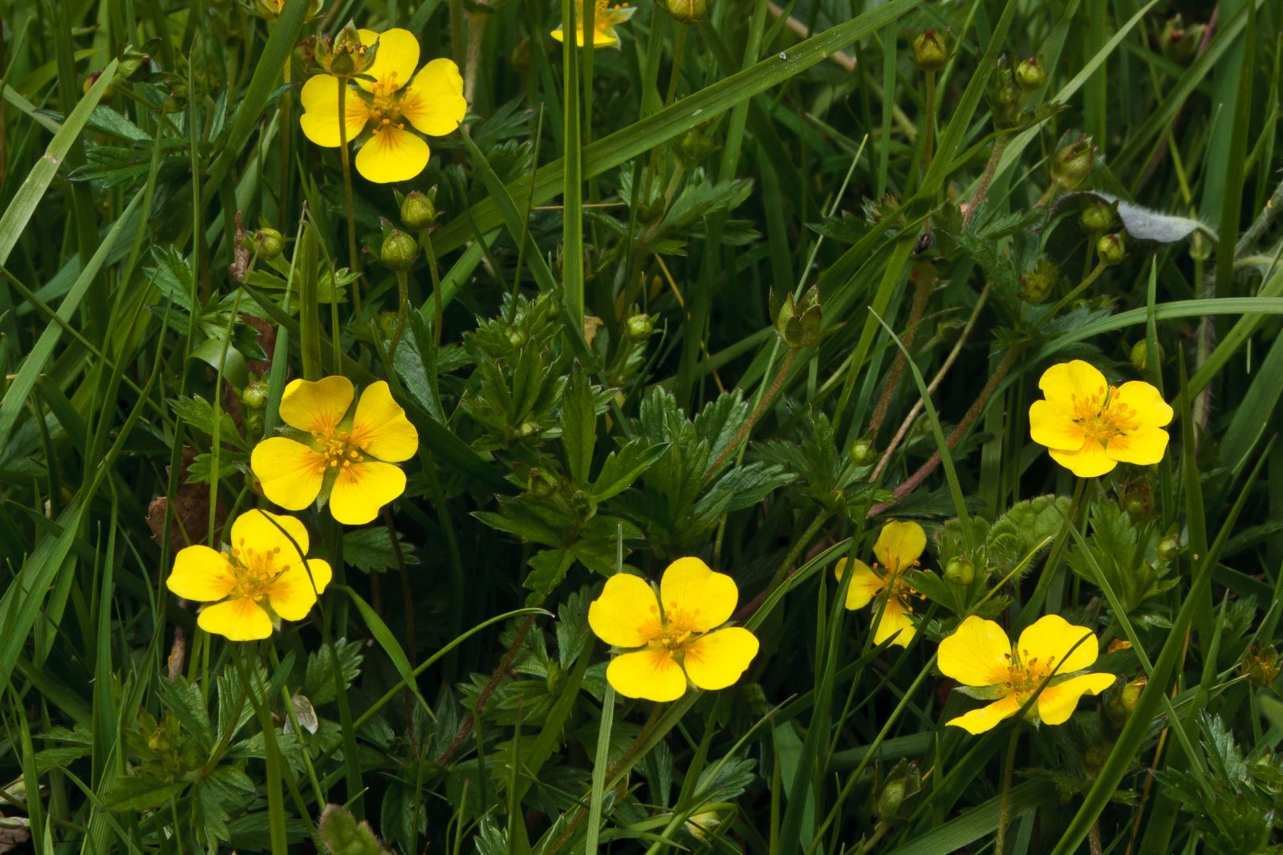
Tormentil

- Tormentil has four-petalled, yellow flowers
- It can be used as a vegetable dye to dye leather red
- Flowers May to Sept
- The roots are used in Bavarian bitter liquor (Blutwurz)
- The Tormentil root has also been used in the past to treat ulcers and gum disease
- In the early 1700's when there was a shortage of trees in Ireland the government awarded £200 to William Maple for discovering that leather could be tanned using Tormentil roots

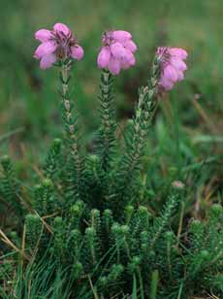
Crossed leaf heather
- Flowers Jul to Sept
- Pink bell-shaped flowers clustered at ends of stem
- Narrow grey-green leaves in whorls of 4
- Prefers boggy areas

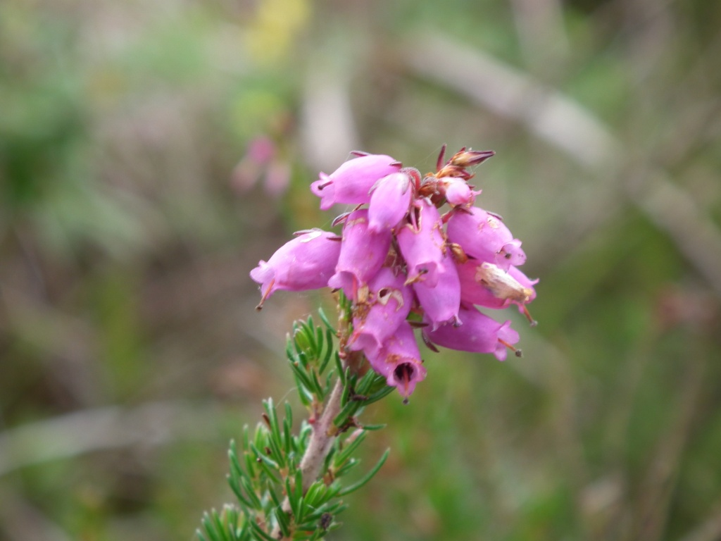
Bell heather
- Flowers Jul to Sept
- Bell Heather is distinctive with its dark purple-pink, bell-shaped flowers forming clusters up the stem, and short, dark green needle-like leaves borne in whorls of three
- Used as yellow dye in Harris Tweed
- Prefers drier, better drained areas

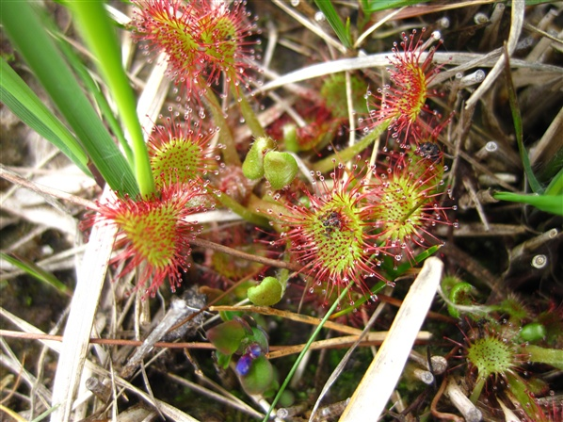
Sundew
- Flowers Jun to Aug
- Many herbalists recommend sundew tea for bronchitis, dry coughs, whooping cough, bronchial cramps and asthma
- Each leaf has hair-like tendrils tipped with glistening droplets attract passing insects. But this 'dew' is very sticky and when the sundew's tendrils detect the presence of prey, it curls them inwards, trapping the insect Eventually, the whole leaf wraps around the prey; the enclosed insect is digested, and the nutrients absorbed by the plant
- Usually lives in wet habitats where the acidic conditions limit the amount of nutrients they can extract from the soil. These plants supplement their diet by catching and digesting insects

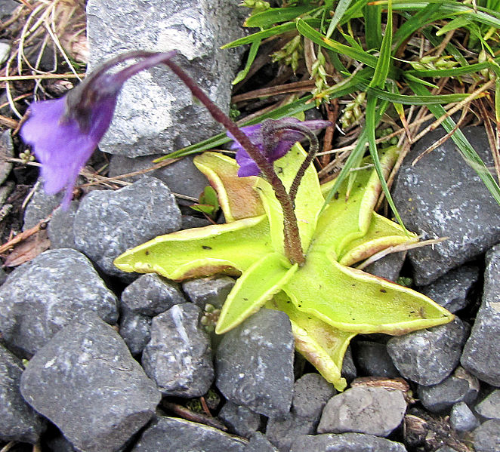
Butterwort
- Flowers May to Jul
- Insectivorous
- Evolved due to habitat not providing enough nutrients
- Used to curdle milk
- Used as a laxative.
- In Welsh, Tafod y gors (tongue of the bog).

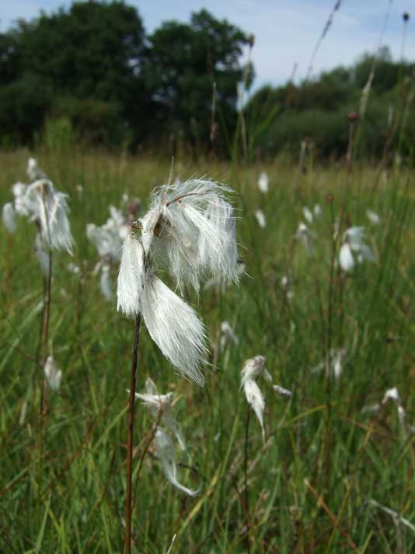
Cotton Grass
- Flowers May to Jun
- Indication of wet areas
- The fluffy white fronds of common cotton grass were once used as pillow stuffing in Suffolk
- In Scotland they used them to dress wounds during the First World War
- Cotton-grass is a member of the sedge family rather than being a grass

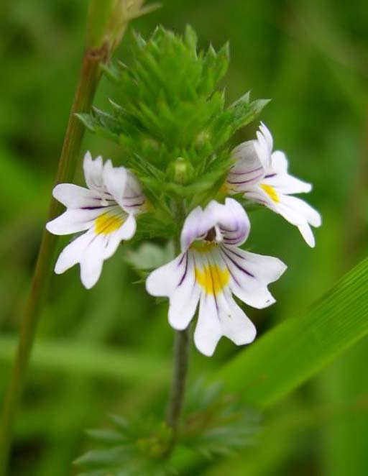
Eyebright
- Flowers Jun to Sept
- Once used as a remedy for poor eyesight
- Eyebrights are semi-parasitic. By attaching themselves to the roots of other plants they steal some of their nutrients.

ht

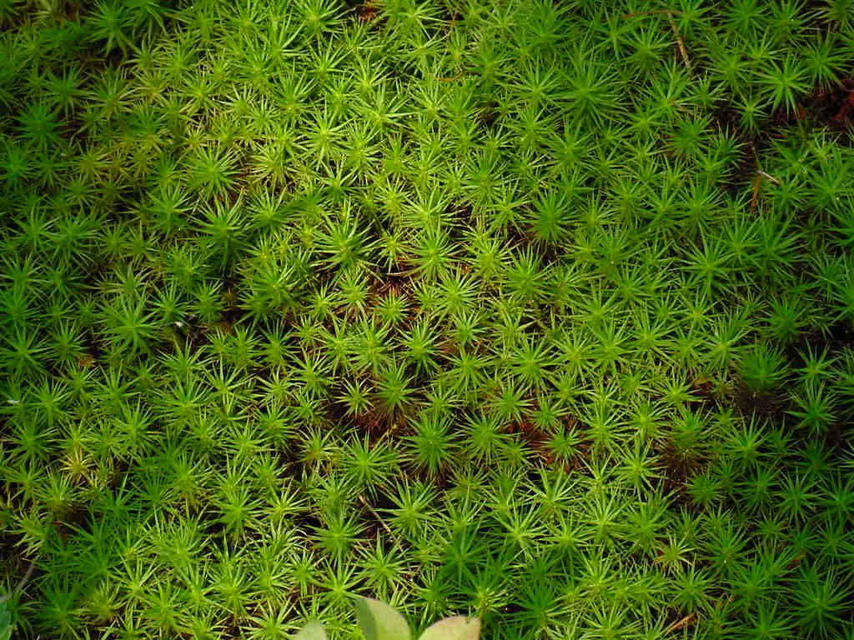
Sphagnum moss
- A walker’s nightmare
- Can hold approx 20 times its dry weight
- Vigorous coloniser, alters PH level, other plants struggle to co-exist.
- Used as insulating material in hanging baskets
- Used for centuries to dress wounds due to absorption, extremely acidic, preventing bacteria growth

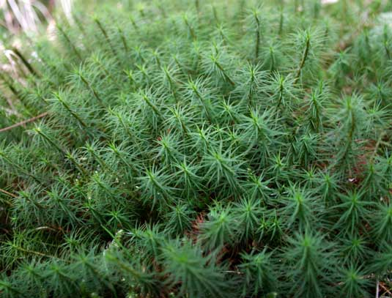
Star moss
- Very common on the hills, grows in large clumps in damp areas
- Used for decorations, brushes and brooms
- Used to make tea to dissolve gall and bladder stones
- Used by model fanatics as Pine Trees

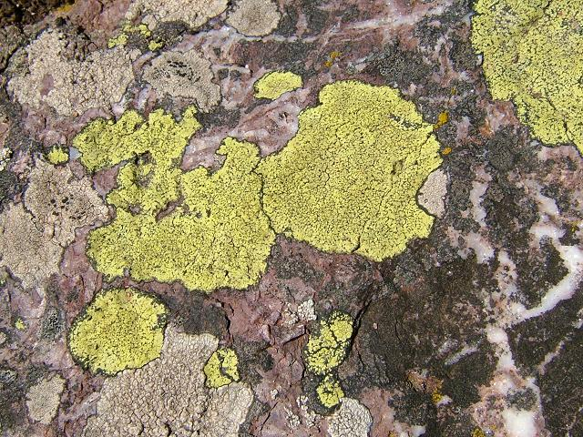
Map makers lichen
- A lichen is not a single organism
- A symbiotic relationship between a fungus and algae
- The fungus creates a body, called a thallus, in which they both live
- The algae use sunlight to produce essential nutrients by photosynthesis that feed both partners
- Grows in mountainous areas where there is clean air
- Flat patch bordered by a black line of spores.
- Grow adjacent to each other, leading to a map-like appearance
- Used by climatologists to determine the relative age of rock deposits
- The assumption is that the largest lichen is the oldest

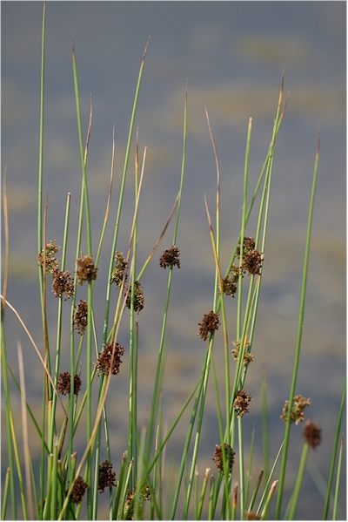
Soft Rush
- Grows to approx 1m high in damp areas.
- Untouched by sheep
- Used as a weaving material.
- Used to make Rush Lights:
  - Old, cheap form of lighting.
  - Rush gathered in summer, soaked, peeled then dried.
  - Dipped in animal fat collected from cold stew. Mutton fat was better than pork fat.
  - Used until beginning of 20th century

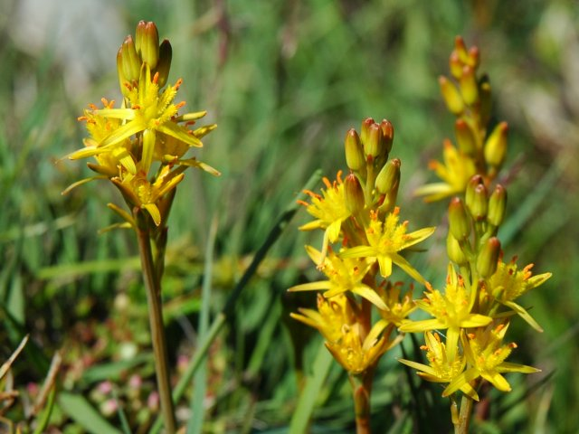
Bog Asphodel
- Used as a colourant to replace Saffron
- Latin name means bone breaker, it was believed that sheep developed brittle bones by eating it.

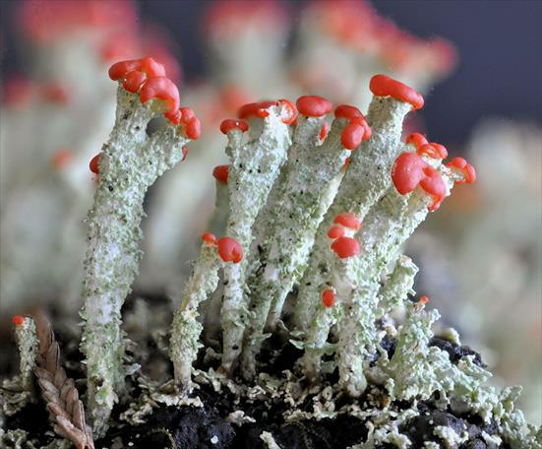
Devils Matchstick
- Red tops are the fruiting bodies of the fungus.
- Between 1 & 2 cm high
- Grows on rotting wood & peat and well-drained soil
- The more lichen you see, the cleaner the air!

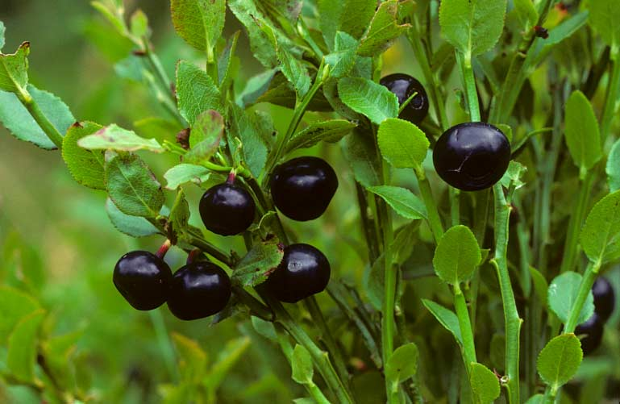
Bilberry
- Flowers May till June
- Berries appear in Aug
- Used to treat Piles and varicose veins
- Provides habitat for Bilberry Bee which is recognisable by its orange bum

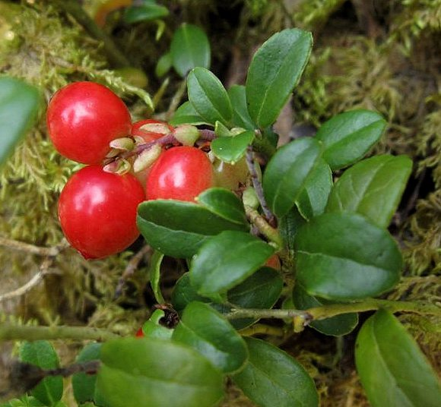
Cowberry
- Oval shiny leaves
- Very acidic
- Used to treat gonorrhoea, arthritis, rheumatism, diabetes and diarrhoea
- Flowers May – Jun
- Berries Jul – Oct

Crowberry
- Flowers in May – June
- Berries in Autumn
- Evergreen shiny, slim green leaves
- Forms dense mats
- Used as an eyewash
- Used as purple dye

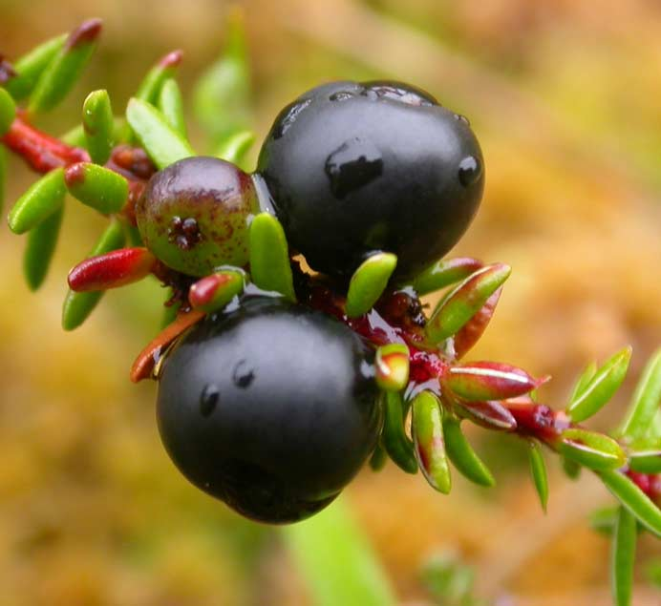

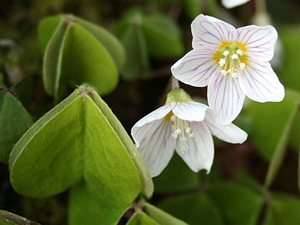
Wood Sorrel
- Flowers in May – June
- Found in woods or previously wooded areas
- 3 heart shaped leaves folded through middle
- Fresh leaves taste like strong green apple.
- Bind up calcium in body leading to nutrient deficiency

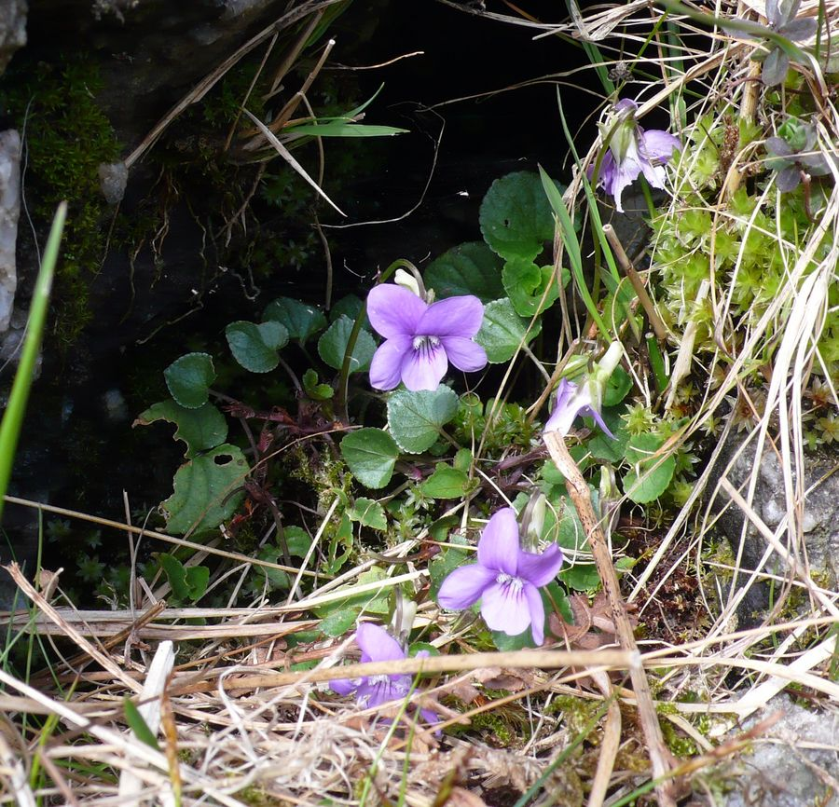

Common Dog Violet
- Found in woodland and grassy mountains
- Welsh name translates to cuckoo socks as it flowers at the same time as the cuckoo is heard
- Folklore suggests its unlucky to pick these and bring to your house as will stop hens laying
- Made into treacle by adding water and sugar
- Considered unrivalled cure for coughs, cold and chest complaints

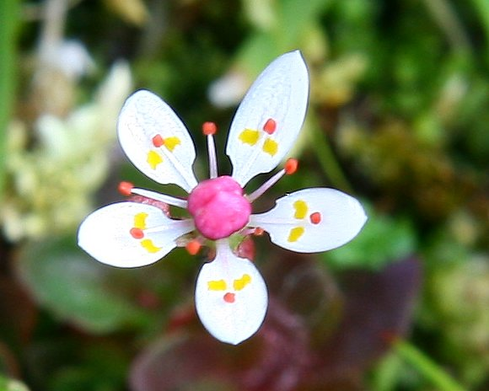
Starry Saxifrage
- Arctic Alpine plant
- One of the lowest altitude Alpine plants
- Grows in wet acidic areas

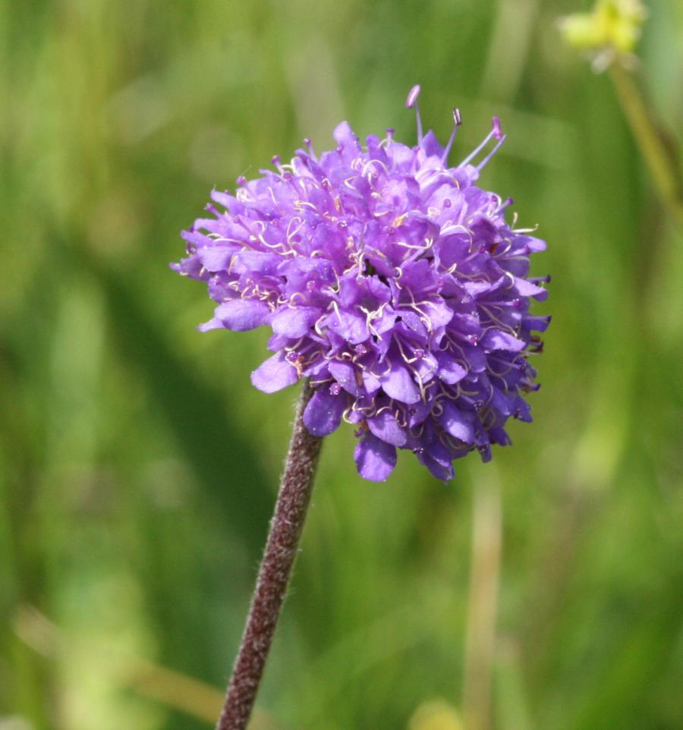
Devils Bit Scabious
- Found in damp grassy places
- Woodland indicator
- Known for all sorts of cures
- Has very short routes as the Devil bit them off!
- Root is boiled and drunk as a cure for the plague (scabious means itch).
- Used to treat exczema, bruising and conjunctivitis
- Green dye is extracted from the leaves

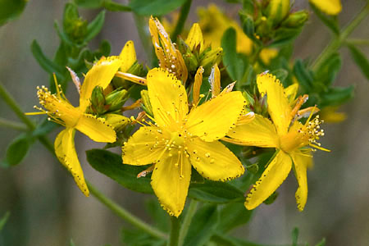
St Johns Wort
- Not commonly seen in the mountains
- Usually found in hedgerows
- On the increase due to reduced sheep grazing
- When crushed, produces red juice (St Johns Blood)
- Used to treat depression and bruising

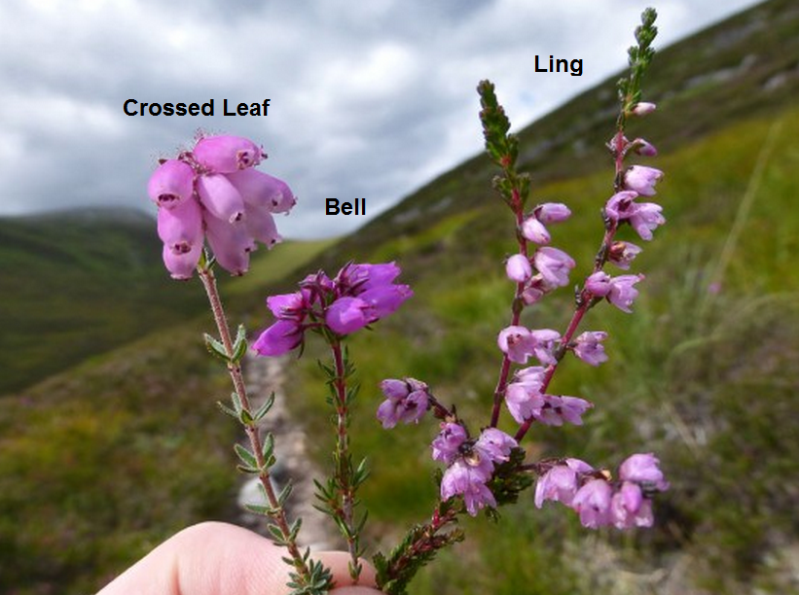
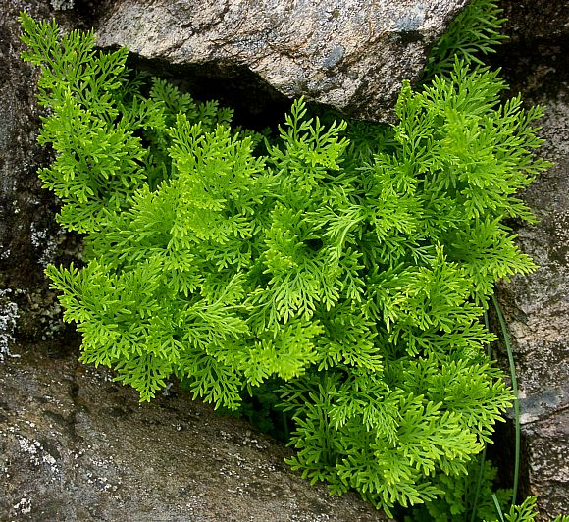
Parsley Fern
- Early coloniser on scree slopes
- Grows on well drained acidic rocks
- Upright fertile leaves
- Sterile lower fronds
- Gets its name from looking like parsley

